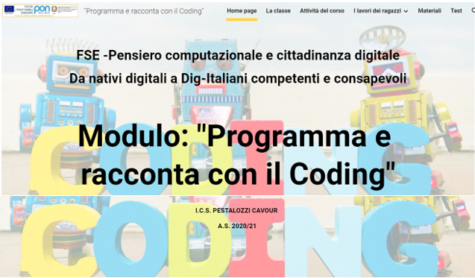

<https://sites.google.com/icspestalozzi-cavour.edu.it/pon-coding2021/home-page>