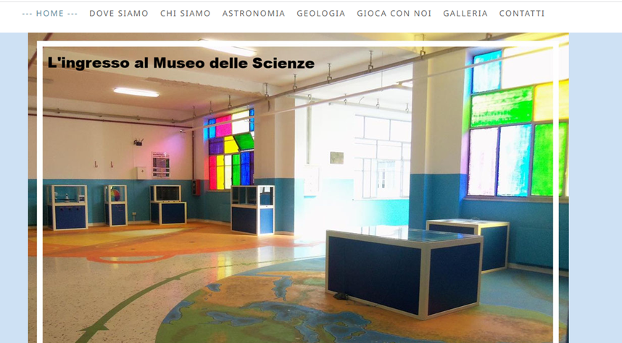

<https://museodellescienze-cavour-pa.jimdofree.com/>

<https://museodellescienze-cavour-pa.jimdofree.com/galleria/>

<http://www.icspestalozzi-cavour.gov.it/>