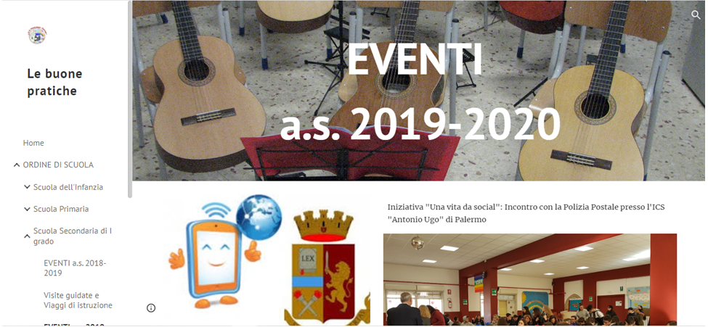

<https://sites.google.com/view/icpestalozzicavour-si-racconta/home?authuser=0>